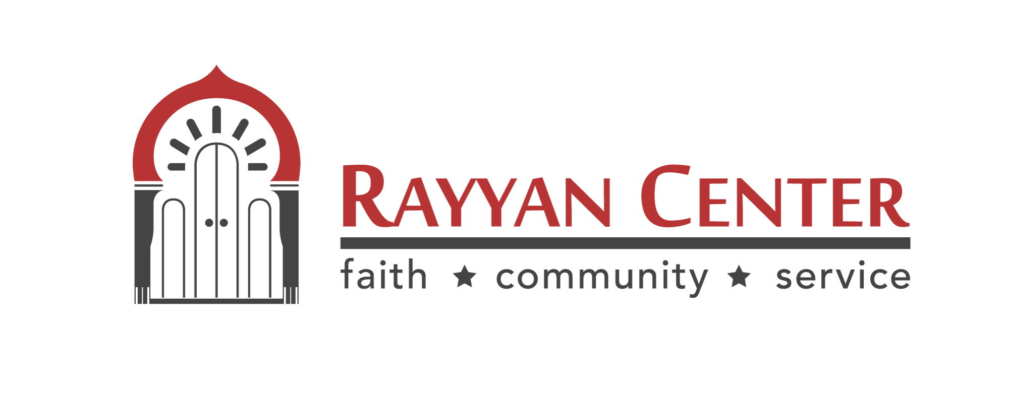
Gym/Social Hall Rental Agreement

DATE OF EVENT:

PURPOSE OF EVENT:

NAME OF RESPONSIBLE PERSON:
ADDRESS:

PHONE #:
EMAIL ADDRESS:

RENTAL RATES
For Parties/Social events: (4 Hour Rental)
For Guests upto 70 (Room): $250 to be paid in advance prior to the event.
For Guests upto 200 (Gym): $600 to be paid in advance prior to the event.
For Guests upto 350 (Gym): $900 to be paid in advance prior to the event.
*Price includes facility set up, cleaning and helpers. (See details on page 3)

For Sports Event ONLY (GYM): $50/hour, due at the time of reservation.Min. 4 hours

The host of the event agrees to pay Rayyan Center the amount of $_______as a deposit during reservation. This amount is non-refundable if cancelled within 30 days of the event. There will be a full refund if the cancellation is done 30 days prior to the event. ___

The host/hostess agrees to the terms and conditions set forth in this packet and also acknowledge having read the same. ___

The host/hostess agrees that this agreement is binding upon the person who signs this contract. It does not cover any other entity and this agreement is non-transferable. ___

The Gym may not be sublet under any circumstances. ___
The host/hostess agrees that there will be no fundraising within the Rayyan Center premises without prior consent from the board, in which case a different application will have to be completed. If the event should include visiting speakers for the event, they have to be authorized by the board. The host/hostess assumes full responsibility for the character, act and conduct of all persons admitted into the premises.___

Rayyan Center shall not be held responsible for any damage and/or injury to any persons including death or for any loss of or damage to the property of the attendees of the event. The host/hostess agrees to indemnify Rayyan Center and hold harmless its agents, servants, employees, volunteers and executive officers from any such occurrences. ___
Any damage(s) that occurs to the facility that are a direct result of the Host/Hostess or their guests will be the responsibility of the signer of this agreement. Rayyan Center will charge the signer of this agreement the cost of the repairs to correct/fix the damage. ___

Wall and ceiling decorations are not permitted. Decoration of chairs and tables is permissible. Any additional decorations may be allowed at the discretion of the rental committee. All decorations must be taken down at the end of the event by the host/hostess. Any damages caused to the appearance of the building/hall due to decorations will be considered as the responsibility of the host/hostess and an additional charge may be imposed on them to rectify the damages. ___

This is a non-smoking facility and this policy will be strictly enforced. Anyone found in violation of this policy will be asked to leave the premises. Under no circumstances is any type of alcoholic beverage or illegal drug allowed on the premises. A violation of this policy will result in the immediate cancellation of the event. The host/hostess acknowledges that in such circumstances, there shall be no refund of any kind and that Rayyan Center has the obligation to report such behavior to the responsible authorities. ___

Music of any kind is not permissible in the premises. ___

The host/hostess acknowledges that he/she shall ensure that the event is conducted according to the Islamic principles. ___

The host/hostess acknowledges that this form has to be completed, signed and submitted along with FULL deposit in order to reserve the hall. The rental term of the hall is 4 hours. Should the event exceed this time, an additional charge of $75 will be charged to the host for every hour. Time starts at time listed on the booking. Time ends when the last of the guest leaves. The hall will be available for decoration or setup only 2 hours prior to the event. Should you need the hall for more than that time, an added fee of $200 will be assessed. ___

Rayyan Center does not entertain storage of any items pertaining to the event in the premises prior to 2 hours before the event. For items/benefits included with the signing of this agreement and payment of deposit, please refer to the form “Hall Rental information” ___

________________________ __________________________
Signature of the host (or) hostess/Date Rayyan Center Management Team/Date

By signing this agreement, the signer agrees that he/she has read this agreement and the attached form named “Hall rental information” completely and has understood it in its entirety and agrees to comply with the conditions set forth in this agreement.
Gym Rental Information

- Maximum capacity of GYM is 350 people in total. ___
- Chairs and Tables will be provided by Rayyan Center. ___
- Serving spoons will be provided by Rayyan Center. ___
- Rayyan Center can provide tea percolators for $25 each at additional cost.___
- Rayyan Center can provide Chafing Dishes at $25 each at additional cost. ___
- All cutlery, table covers and supplies needed (plates, cups, napkins, bowls, tea, sugar, garbage bags, etc.) are the responsibility of the host/hostess. ___
- Host/hostess are allowed to decorate and must be removed after event. ___
- Confetti, Glitter, Scotch tape and nails may NOT be used for decorating.
- Rayyan Center will provide 1 or 2 helpers for maximum of 6 hours to help the host/hostess with setting up the tables and chairs, filling up the buffet tables, tea percolators and clean up. ___
- The helpers will come 1 hour prior to event and stay 1 hour after the event for maximum of 6 hours. Any additional time will be charged at $25/hour per helper. The host/hostess are responsible to pay for additional time. ___
- All trash generated at the event must be placed in the dumpster and trash bins replaced with new empty trash bags. ___
- If the event goes past midnight, there will be an additional charge of $100/hr. ___
- Kitchenette can only be used for setting up food. NO Cooking allowed. ___
- NO Children are allowed in the Kitchen and storage room areas. ___
- NO Food/drinks are allowed outside of the designated areas. ___
- The rental does NOT include access to the second floor at all. ___
- Gym Sound system with 1 mic. can be provided upon request. ___

_______________________________ _____________________________
Signature of the host (or) hostess/Date Rayyan Center Management/Date

By signing this agreement, the signer agrees that he/she has read this agreement and the attached form named “Hall rental information” completely and has understood it in its entirety and agrees to comply with the conditions set forth in this agreement.

